Excel Mid-Term Exam
Determining Profit on Items Sold

Purpose: To demonstrate the ability to enter and copy formulas, modify background and font colors, and apply formatting to a worksheet.

Problem: You are an accountant for an automotive parts supply company. You specialize in parts for Chevrolet and Lexus automobiles. You are trying to determine the amount of profit made on a recent sale. You know the quantity of items sold, the original purchase price, and the price that each item was sold for during the sale.

Instructions: Perform the following tasks to create the worksheet shown in Figure MTE-2.

1. Open the data file Excel Mid-Term Exam Data.xls (as seen in Figure MTE-1. You will enter formulas for columns E, F, and G and for rows 12 through 17.
2. Use the following formulas to determine the Total Initial Item Cost, Total Gross Sales, and Total Profit.
(a) Total Initial Item Cost = Quantity Sold * Initial Item Cost
(b) Total Gross Sales = Quantity Sold * Item Sale Price
(c) Total Item Profit = Total Gross Sales – Total Initial Item Cost
3. In cell B12, determine the Totals Sales by finding the sum of Total Gross Sales. In cell B13, determine the Total Cost by finding the sum of Total Initial Costs. In cell B14, find the Total Profit by subtracting the Total Cost from the Total Sales. In cell B15, find the Percent of Profit by dividing the Total Profit by the Total Cost. In cell B16, use the MAX function to find the greatest Total Item Profit. In cell B17, use the MIN function to find the least Total Item Profit.
4. Apply the following formatting to the worksheet titles in cells A1 and A2.
(a) change the font to bold
(b) change the font to Times New Roman (if necessary) (c) increase the font size of cell A1 to 24 point and of cell A2 to 18 point
(d) center the titles across columns A through G
(e) change the background color to dark blue (column 6, row 1 of the Color palette) and the text to yellow
(column 3, row 4 of Color palette).
(f) draw a bold outline around the range A1:G11
5. Using the buttons on the Formatting toolbar, apply Currency style format with two decimal places to the ranges C4:G4, B12:B14, and B16:B17. Apply the Comma style format with two decimal places to the range C5:G11. Apply percent style format with just one decimal place to cell B15.
6. Bold, italicize, and center the column titles, enable wrap text, and draw a bold border under them in the range A3:G3. Change the background color for the same range to lavender (column 7, row 5 of the Color palette), and change the text color to light blue (column 5, row 5 of the Color palette).
7. In the Total Item Profit column, change the background color to aqua (column 5, row 3 of the Color palette). Draw a bold outline around the values in column G.
8. Bold the item numbers and summary headings (range A4:A17), and change the font to MS Sans Serif or a similar font (if necessary). Widen column A to 17.00 points. Change the background color of the range A12:B17 to sky blue (column 6, row 4 of the Color palette).
- Change the height of row 1 to 39.00 points. Change the height of row 12 to 21.00 points and the width of columns C through G to 10.00 points.
- Rename the worksheet tab from Sheet 1 to Sales Profits and check the spelling on the entire worksheet.
- Use the Conditional Formatting command on the Format menu to color the background yellow of any cell in the range F4:F11 that has a value less than $1,500.
- Enter your name in cell A20. In the cells directly below your name, enter your course identification, Mid-Term Exam, date, and instructor's name.
- Save the workbook using the file name, Yourname - Excel Mid-Term Exam, where Yourname is your own last name.

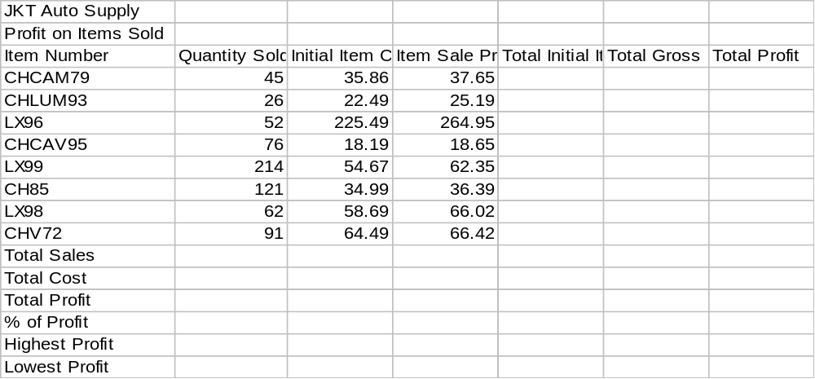

Figure MTE-1

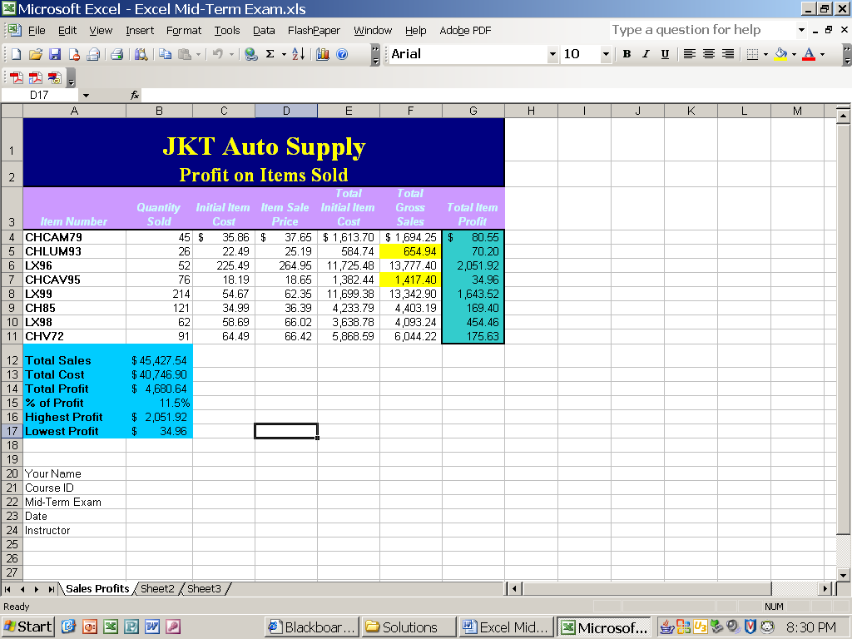

Figure MTE-2

